**Steps to integrate OpenGL Libraries:**

You need two libraries for the project

* FreeGlut ­ An implementation of OpenGL Utility toolkit (GLUT) to create and manage windows in OpenGL context.
* Glew ­ The OpenGl extension wrangler library.

The following steps will help you configure a visual studio project to use FreeGlut and Glew.

* Download binaries for [FreeGlut](http://files.transmissionzero.co.uk/software/development/GLUT/freeglut-MSVC.zip)
* Download binaries for [Glew](https://sourceforge.net/projects/glew/files/glew/1.13.0/glew-1.13.0-win32.zip/download)
* Extract both the downloads at appropriate location
* Create an empty visual studio project named Assignment_1.
* Let us assume that you have stored the Assignment_1 project in C:\Desktop
* Create three folders as follows
  + C:\Desktop\Assignment_1\Assignment_1\Dependencies
  + C:\Desktop\Assignment_1\Assignment_1\Dependencies\freeglut
  + C:\Desktop\Assignment_1\Assignment_1\Dependencies\glew
* We now need to copy certain files into these project dependencies
* Go to
  + the_location_where_you_extracted_freeglut\freeglut­MSVC­3.0.0­2.mp\freeglut\in clude\GL
  + Copy all the header files from this folder into C:\Desktop\Assignment_1\Assignment_1\Dependencies\freeglut
* Go to
  + the_location_where_you_extracted_freeglut\freeglut­MSVC­3.0.0­2.mp\freeglut\li b
  + Copy the file named freeglut.lib into C:\Desktop\Assignment_1\Assignment_1\Dependencies\freeglut
* Goto
  + the_location_where_you_extracted_glew\glew­1.13.0­win32\glew­1.13.0\include\ GL
  + Copy all the header files from this folder into C:\Desktop\Assignment_1\Assignment_1\Dependencies\glew
* Goto
  + the_location_where_you_extracted_glew\glew­1.13.0­win32\glew­1.13.0\lib\Rele ase\win32\
  + Copy the file glew32.lib into C:\Desktop\Assignment_1\Assignment_1\Dependencies\glew
* Go to
  + the_location_where_you_extracted_freeglut\freeglut­MSVC­3.0.0­2.mp\freeglut\bi n
  + Copy freeglut.dll into C:\Desktop\Assignment_1\Debug (Note: You might have to create a Debug folder at this location if it does not exist already)
* Go to
  + the_location_where_you_extracted_glew\glew­1.13.0­win32\glew­1.13.0\bin\Rele ase\Win32
  + Copy glew32.dll into C:\Desktop\Assignment_1\Debug
* Go to visual studio and Right Click on the project name(i.e Assignment_1) in the solution explorer and select properties
* Select Linker ­> General
* 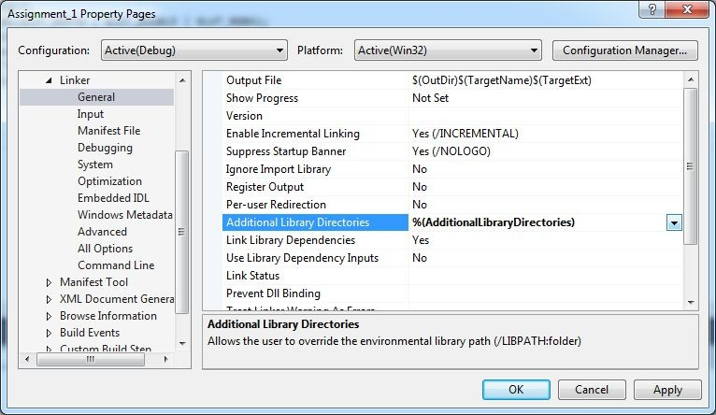Select Additional Library Dependencies and click edit
* Add freeglut and glew dependencies

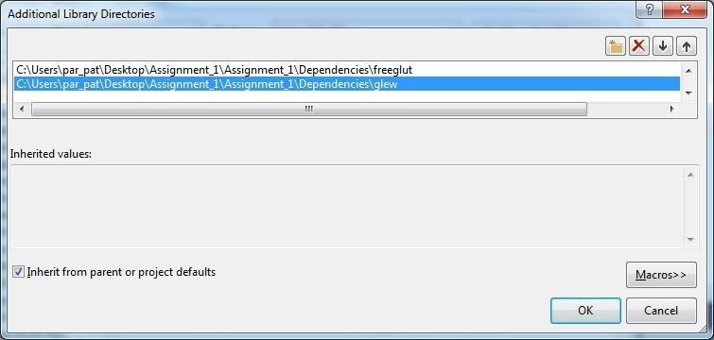

* 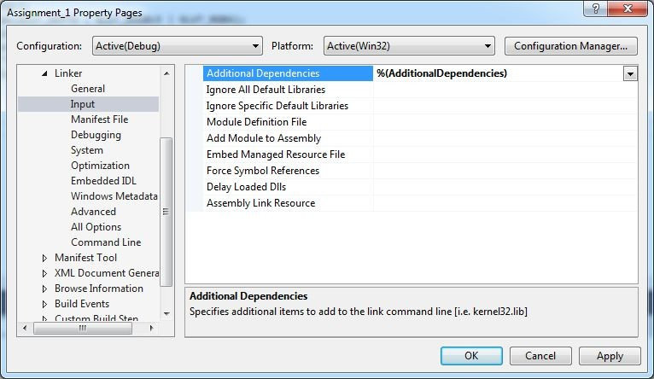Go to Linker ­> Input ­> Additional Dependencies ­> edit
* Add the following three lib files
  + opengl32.lib
  + freeglut.lib
  + 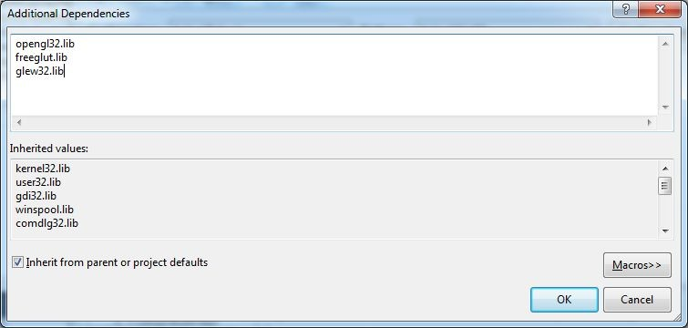glew32.lib
* Your project is now configured to use freeglut and glew.
* You can now try the examples firstWindow.cpp and triangle.cpp available on moodle.